**Forum:** Disarmament Commission

**Issue:** Facilitating reconstruction and peace talks in the aftermath of the Yemeni Civil War

**Student Officer:** Sharanya Trivedi

**Position:** Chair of Disarmament Commission

Introduction

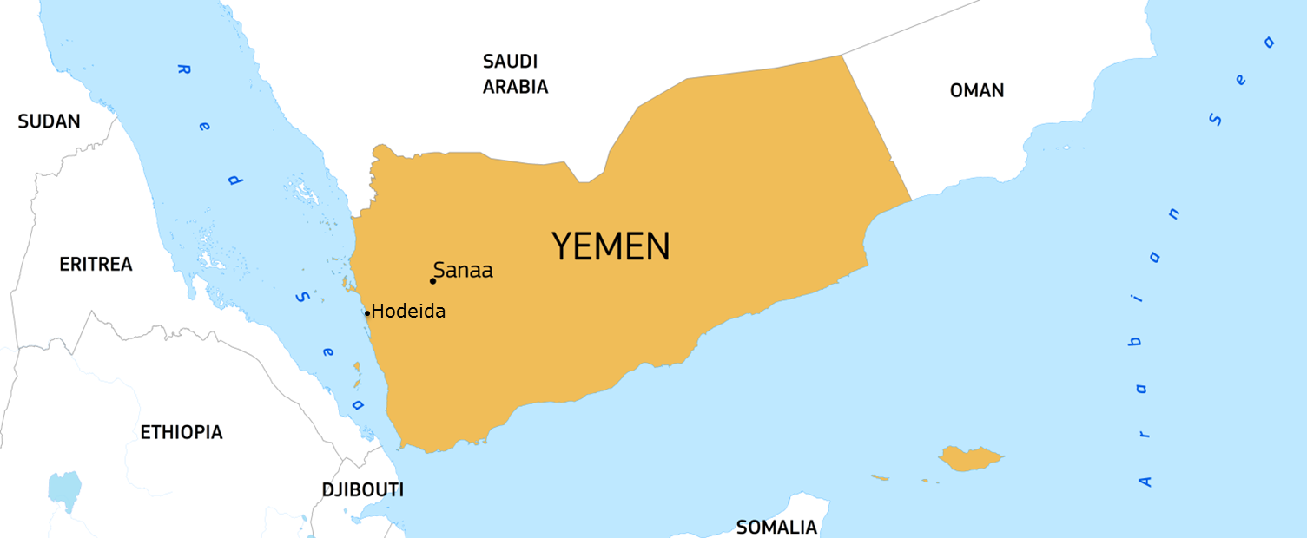 The Republic of Yemen is situated in the Middle East towards the southern end of the Arabian Peninsula, enclosed by the Arabian Sea, the Red Sea, and the Gulf of Aden. Despite it’s clear strategical advantage of being nearby to the world’s most key energy passage, namely the Strait of Hormuz, Yemen is one of the poorest Middle Eastern countries. This is mainly due to its history, regarding the country’s experience with turbulence, division, and civil war.

*Figure 1: Yemen and neighbouring countries*

Currently, the country is facing one of the most disastrous crises in its short but eventful history with the overthrow of its government by an insurgent movement led by the Houthis rebel group. Simultaneously, there is recurrent international involvement mainly by Saudi Arabia and Iran, which back the former government and the rebel forces respectively. What causes even more tension is the growing expansion and growth of the terrorist group al‐Qaeda in the Arabian Peninsula (AQAP) which is based in the eastern region of the country. Terrorist activity has concerned the United States, which has sent forces in the region fighting against AQAP and backing the government, as well as Saudi Arabian forces against the Houthis.

On a humanitarian level, the country is in an emergency, as labelled by the United Nations, which emphasised the brutality and complexity of the situation in the country. Struck by serious diseases such as malaria and hepatitis A, and concurrently experiencing a food and water crisis, Yemen has been plunged into a chaos of humanitarian suffering, never-ending conflict and arbitrary foreign interference.

Definition of Key Terms

Sunni Muslims

Sunni Muslims account for around 85% of the global Muslim population and are most commonly described as orthodox.The Sunnis believe that Muhammad had no rightful heir and that a religious leader must be elected through a vote conducted among the community's people.

**Shia Muslims**

Shia Muslims account for around 15% of the global Muslim population. The sole countries that have a Shiite majority in the Middle East are Iran, Iraq and the Gulf nation of Bahrain. Shiites believe that only Allah, the God of the Islamic faith, can appoint religious leaders, therefore, all successors must be direct descendants of Muhammad.

**Arab Spring**

A sequence of anti-government protests, uprisings, and armed rebellions that spread across most of the Islamic world in the early 2010s. It began in response to oppressive regimes and a low standard of living, commencing with protests in Tunisia.

**Houthis**

The Houthis refer to a Yemeni militant movement stemming from the country’s impoverished north‐western region. Often characterized as Ansar Allah, or "Partisans of God", the Houthis obey to a branch of Shia Islam known as Zaidism and fight for the protection of their religious and cultural beliefs. The group is accountable for the insurgency which emerged in 2004 and was led by the leader and founder of the movement, Hussein al‐ Houthi.

**Al-Qaeda in the Arabian Peninsula (AQAP)**

AQAP is a Sunni extremist group based in Yemen that has coordinated several high‐profile terrorist attacks. The group arose in January 2009 following an announcement that Yemeni and Saudi terrorists were uniting under a common banner. The group has targeted local, US, and Western interests in the Arabian Peninsula, but is now focusing on a global strategy.

General Overview

Historical Background

Yemen Arab Republic (1960-2004)

Yemen’s early history is characterized by constant unrest and political instability. During the 1960’s, the country was separated into two parts - the northern part, which was under the rule of a closed group of Imams, and the southern part, which at the time was a British colony. By 1962, however, following a military coup, the northern government was overthrown, and soon after the Yemen Arab Republic was declared. However, the event was accompanied with a fierce outbreak of civil unrest in which Egypt and Soviet Union (USSR) supported the revolutionaries and Saudi Arabia stood openly in favour of the country’s monarchists. In 1969 the war came to its end, marking the downfall and decline of the royal class.

Meanwhile, the southern port of Aden turned into an area of great strategical and geopolitical significance, since it was positioned at the opening of the Red Sea. Having expanded its borders in 1937, the region soon thrived on a fiscal level, earning the title ‘Aden Protectorate’ on account of its growing power. The 1960s was without a doubt a decade of transition and advancement for the southern part of the country. Following the establishment of the Nationalist Liberation Front (NLF), a revolution of the native Yemeni population broke out opposing British rule. Its success in following years led to a central event in the country’s recent history, specifically the founding of the People's Republic of Southern Yemen in 1967. The People's Republic of Southern Yemen was so deeply influenced by socialistic ideologies –unlike its neighbouring countries‐ that it was often regarded the only Marxist state in the entire Arab world.

Another significant historical milestone for Yemen can be traced back 25 years ago when on the 22nd May of 1990, the northern and the southern governments decided upon the joint governing of Yemen and therefore the integration of the two countries with Ali Abdullah Salah serving as the first official Yemen President. The position of Vice‐President was assigned to the former President of South Yemen, Ali Salim al‐Beidh, while at the same time a united parliament was formed and a constitution was agreed upon.

However, control over power remained a contentious issue between the North and the South with both demanding exclusive rule over Yemen. The 1994 Yemeni Civil War soon broke out. The North's military dominance was soon made clear despite the South’s substantial attempts to stand out and appeal to public interest. Despite efforts made in the name of political democracy and stability to achieve compromise and reconciliation between the north and the south (signing of peace agreement in Amman, Jordan on 20th February 1994) the civil war was not to come to its end yet. Tension between the two sides resulted in an armed conflict of a great scale. Ultimately, the pivotal battle between the two armed forces resulted in the defeat of the southern part of Yemen which faced severe losses during the battle. Following Northern Yemen’s victory, multiple Yemeni Socialist Party leaders and other political figures of the south fled the country. The July 1994 civil war in Yemen ended leaving the country financially weak and politically but also socially divided.

Beginning of Houthi Insurgency

In June 2004 Yemen was struck by the Houthi insurgency which arose as a result of the convincing religious accusations targeting the country’s government. Dissident cleric and Shia’s firm supporter Hussein Badreddin al‐Houthi, was one of the chief political figures responsible for the anti‐ governmental movement which was taken as an attempt to overthrow the existing government and implement Zaidi religious law. The rebellion took the form of a fight against discernment and government hostility. Houthi was killed by Yemeni troops and one of his brothers became the new leader of the movement. Between 2004 and 2010, the rebellion continued in greater force resulting in a violent armed conflict which led to frequent clashes between the two sides.

In 2011, the Arab spring’s reach also stretched to Yemen, and the Houthis used the anti‐ government protests for their cause. The pressure exerted by the rebels made President Saleh resign after a 33‐year rule. In February 2012 Abd Rabbuh Mansur al‐Hadi was elected as the new president, however the ferocity and conflict triggered by the insurgency has not yet reached an end, ongoing even till today. 

The deterioration of the situation in Yemen

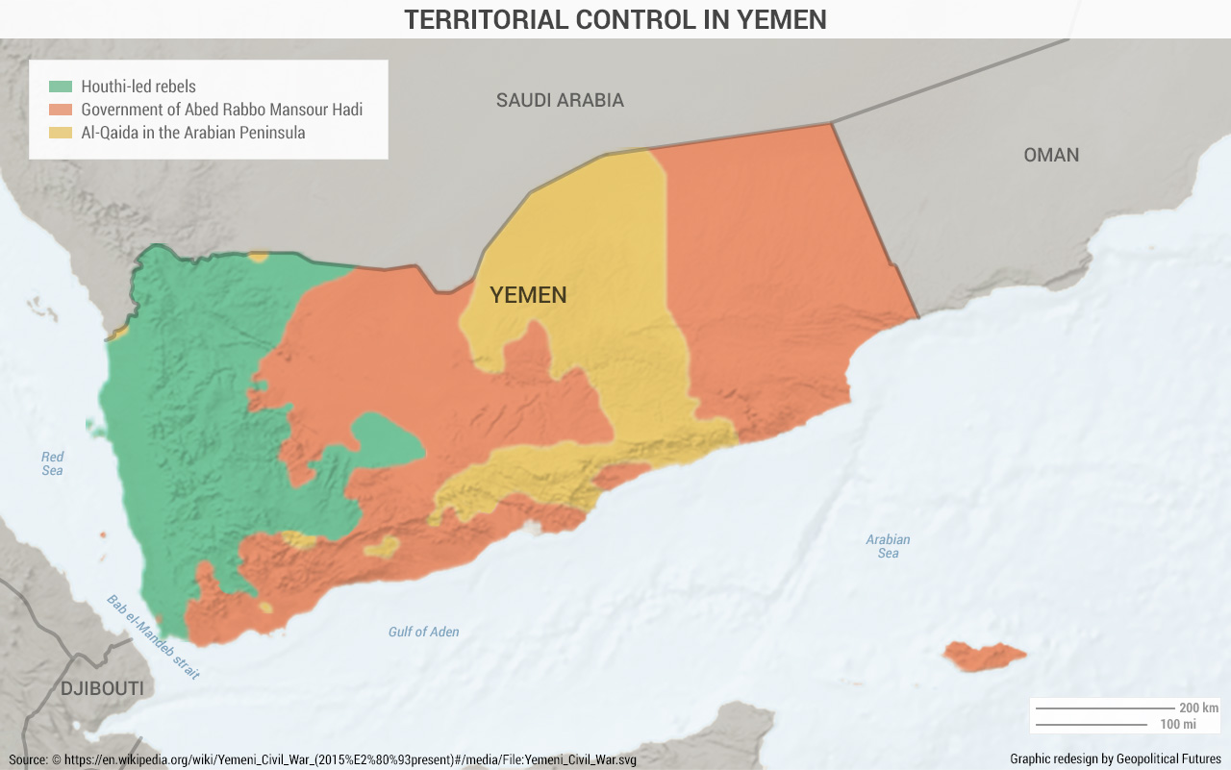The recurrent clashes between the rebel groups and the government forces were accompanied by a number of terrorist attacks such as suicide attacks, a bomb explosion in front of the British embassy and several kidnappings whose hostages ranged from civilians to political figures.

It was even said that a large‐scale terrorist attack was about to take place in the Arabian Peninsula. According to Yemeni officials, the plan was conceived as well as organized by al‐Qaeda and was fortunately prevented by the government. Intercepted suspicious communications between the leader of al‐Qaeda and the head of the organization in Yemen, in combination with the unexpected arrival of numerous militants to the capital Sana’a, alerted the Yemeni officials, which resulted in further investigations regarding the issue. Ultimately, the plan was foiled, revealing the targets of the terrorist attack, which included multiple embassies and offices, the Yemeni military headquarters, as well as oil and gas pipelines.

*Figure 2: Control in Yemen*

It is, however, argued that the aforementioned anti‐terrorism mission that the government claimed to have accomplished, was actually a product of the government itself in an attempt to prove that it could effectively maintain national security and limit the actions of AQAP in the region.

A considerable step towards securing stability in the country was made in March 2013 with the opening of the National Dialogue Conference. Its aim was to suggest ways to improve Yemen’s economy, eradicate corruption, deal with the rebel groups and endorse provisions for a new constitution. The members of the conference included 565 representatives from political parties, women's groups, youth movements, and other civil organizations. Despite high anticipation, the conference did not have expected results, ending several months behind schedule. Nevertheless, there were some important decisions reached, such as to find an anti‐corruption board, bring an end to childhood marriage, take measures for the empowerment of women, establish a federal system of government, and make efforts to minimize the marginalization of southern population. In response to the conference, a plan was laid out by the presidential committee in February for Yemen to become a federation of six regions.

Meanwhile, Shia and Sunni groups of the country joined forces with the Houthis. Together they entered the capital Sana’a two months later and settled there for what was thought to be temporary. The pressure exerted on the government by the rebel forces led President Hadi to agree on the formation of a new government whose prime minister would be nominated by the Houthis. In his attempt to peacefully come to terms with the rebels Hadi promised to reduce the price of fuel, but still the Houthis considered the concessions insufficient. Inevitably, a fight between the rebels and the security forces broke out in Sana’a, resulting to the Houthis domination. The Houthis gained control of the capital of Yemen; an incident viewed by the rebels as their greatest accomplishment and by the government as its most significant loss so far.

On 20th September, the UN attempted to facilitate talks between the government and the rebels in order to sign a peace agreement, which called for the resignation of Mohammed Basindwa the country’s Prime Minister, the withdrawal of the rebel forces from Sana’a, the establishment of a "technocratic national government" and the implementation of the provisions of the National Dialogue Conference, and allowed the Houthis to have more representation in parliament. The Houthis, however, refused to withdraw their forces from Sana’a and therefore rejected the peace agreement. In October, Khaled Bahah, Yemen's former ambassador to the UN, was named prime minister.

Recent Events

In January 2015 an intensification of the fighting between Houthi rebels and government in Sana’a was noticed. Under these circumstances a draft constitution was adopted that called for Yemen to become a federation of six regions, a concept that had emerged from the National Dialogue Conference. The Houthis however stated that they are firmly opposed to the country’s six‐region division.

The Houthis then surrounded the presidential palace complex taking his chief of staff hostage. On January 21st the Houthis and the government signed a cease‐fire, which demanded the withdrawal of the rebel 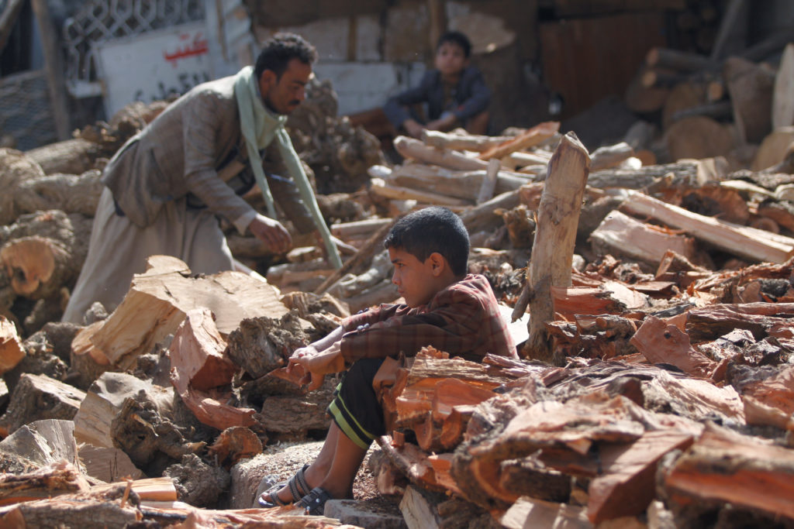forces from the presidential palace, the cancellation of the proposed regional plan and the political empowerment of the Houthis in parliament. The Houthis, however, refused to abide by the ceasefire. One day later Hadi, the Prime Minister and the cabinet all resigned as a result of the pressure exerted by the Houthis.

*Figure 3: Civilians affected by the situation*

In early February, the Houthis decided upon the Parliament’s dissolution and announced its replacement by a national council that would then formulate a committee to name a new president. During this escalating situation Saudi Arabia withheld aid to Yemen on account of the Houthis' ties to Iran. At this point the UN attempted to intervene and facilitate talks between the rebels and rival political parties unfortunately with minimal success.

As tension continued to peak, on February 6th, the Houthis announced that the newly created five‐member ‘presidential council’ would form a transitional government for two years. In addition to that, a transitional national council comprised of 551 members would be established as a replacement of the former parliament. However, many Sunni governors in the provinces rejected these measures, as they are loyal to the overthrown former government, which leaves Yemen in a highly unstable situation without an effective central government.

What elevates the situation further is that former president Hadi managed to escape his house arrest on February 21st and has since then withdrawn his resignation, stating that all actions taken by the Houthis were insignificant and illegitimate.

At the same time, Al‐Qaeda in the Arabian Peninsula (AQAP) continues to grow in strength and influence. AQAP embraces Sunni Islam in contrast with the Houthis who observe Shiite Islam. It is on the basis of such rigid differences that the two groups have been in conflict with each other taking considerable toll on the civilians.

The involvement of foreign powers in the Yemeni crisis has significantly exacerbated the situation making it even more complex and difficult to get under control. Iran appears as a definite supporter of the Houthis insurgency while Saudi Arabia has made clear its opposition to the group and has often taken action against them. The United States of America is also one of the major countries involved in fighting against Al-Qaeda, since they are one of the major supporters and endorsers of Saudi Arabia. The terrorist group has attracted the attention of the US, in the context of counter-terrorism measures.

Key Players

Islamic Republic of Iran

Iran is considered to be the Houthis’ strongest supporter on an international level and their greatest financial reserve. Apart from the economic support that the country provides to the group, many claim that Iran has often reinforced the insurgent movement militarily. The strong ties that have been developed between the rebels and the Iranian government are a product of similar geopolitical goals that the two sides share. More specifically, Iran questions Saudi and U.S. dominance of the region and the Houthis seek to challenge Hadi’s government which has always been supported by Saudi Arabia and the United States. On that basis it is clear that Houthis’s alliance with Iran stems from a mutual opposition to Saudi Arabia’s and the USA’s involvement in the issue.

Kingdom of Saudi Arabia

Saudi Arabia is one of the major countries involved in the Yemen crisis as a result of the steady support they have expressed towards the former Yemen government. With that being said, the Houthi insurgency has been regarded with strong disapproval by Saudi Arabia, leading to unilateral military operations against the rebel forces. The insurgency is seen as a major threat to the oil‐rich kingdom which regards Houthis as a hostile neighbour backed by a regional rival, Iran. Moreover, since Saudi Arabia is primarily a Sunni country, the establishment of a Shia Muslim country ruled by the Houthis on its southern border is far from desirable for Saudi leadership. Furthermore, Saudi Arabia has formed an alliance of Sunni‐majority Arab states including Bahrain, Egypt, Jordan, Kuwait, Morocco, Qatar, Sudan, and the United Arab Emirates. Saudi Arabia as the dominant party of the coalition that has launched in cooperation with the United States a Saudi‐led air campaign against the Houthi rebels in an attempt to limit the impact of Iran over Yemen. Following nearly month‐long airstrikes, the Saudi government announced in April 2015 that it would terminate its attacks. Although it remains unknown whether this decision will open the way for peace talks between the rival parties in Yemen, there is no doubt that Saudi Arabia will continue to play a key role in Yemen crisis on account of its plentiful wealth and strong political influence.

United States of America

Over the last decade, the United States of America’s presence in Yemen has become more and more apparent on account of the multiple USA interests in the region. First of all, Yemen is considered as one of the key countries in regard to the safe transportation of oil from the Arabian Peninsula and more precisely from Yemen’s neighbouring country Saudi Arabia. Supporting security and stability in Yemen is viewed by the USA as a crucial step towards ensuring the unthreatened transport of oil through the country and the control of the international oil trade.

On that basis, the US is fully backing the Saudi‐led intervention in Yemen which tries to prevent Iran from gaining power over the country through the Houthi uprising. US navy has recently made its presence clear in the area, since a strengthened armada of US warships has reached Yemen’s coast in April 2015. Moreover, since Yemen is home to one of Al Qaeda’s most active branches, Al Qaeda in the Arabian Peninsula, it has appealed to US attention in the perspective of counter‐terrorism. The US, through their support of Saudi Arabia, has effectively caused the deaths of countless civilians through multiple airstrikes.

Al-Qaeda in the Arabian Peninsula (AQAP)

AQAP is an active terrorist group that has largely profited from the ongoing rivalry and whose base is in eastern Yemen. Coordinating multiple violent jihadi terrorist attacks, targeting both civilians and soldiers, not only in many of the biggest cities of Yemen but also out of the country’s borders, AQAP is fighting against both the Houthis, the government forces and American anti‐terrorism troops which are currently based in the country.

Previous Attempts to Solve the Issue

The Gulf Cooperation Council’s involvement in the Yemen crisis has determinedly influenced the situation in the country. United Arab Emirates, Saudi Arabia, Bahrain, Kuwait, Oman and Qatar, as the six members of the GCC, agreed on the launching of military operations in Yemen against the Iran‐backed rebels. These operations included consecutive airstrikes and aerial as well as naval blockade aiming to hold back the Iran‐backed Houthi rebels. The intervention began in 2015 in response to the former Yemeni government’s appeals for international assistance. Soon after that, Saudi Arabia formed a coalition of nine Arab states namely Egypt, Morocco, Jordan, Sudan, the United Arab Emirates, Kuwait, Qatar and Bahrain heralding a military campaign known as Operation Decisive Storm. The US has been a contributing factor to the campaign having provided background support to the coalition, such as intelligence and logistical support as well as weaponary.

On 21 April 2015, following Saudi Arabia’s official announcement, the Operation Decisive Storm was brought to its end. The coalition decided on a political rather than military approach to the Yemen crisis, which they called Operation Restoring Hope. Although the operation mainly focuses on peace talks, the coalition did not ignore the chance of a new military intervention in the face of future threats posed by the rebels or their allies. Even though Operation Decisive Storm had been a substantial attempt to limit the expansion of the rebel groups, blockade of the country as part of the campaign led to a humanitarian disaster which left 78% of the Yemeni population in urgent need of food, water and medical aid.

UN Involvement, Relevant Resolutions, Treaties and Events

The United Nations and especially the Security Council have made some key efforts to steady the situation in Yemen. Below are the Security Council resolutions focussing on the Yemen crisis:

* Security Council Resolution 2014 (21st October 2011)  Approved the Gulf Cooperation Council’s initiative for a peaceful transition of power in which President Saleh promised to hand over his position to his deputy Adbrabbuh Mansour Hadi.
* Security Council Resolution 2051 (12th June 2012) Addressed the second phase of the transition and explained how the exact implememtation process would be conducted.
* Security Council Resolution 2140 (26th February 2014)  The resolution authorised the next steps of the political transition and imposed sanctions on those suspected to pose a threat for the peace, security, or stability of Yemen.
* Security Council Resolution 2201 (15th February 2015)  Strongly disapproved of the Houthis’ decision to dissolve parliament and expressed its disagreement with the capture of government institutions by the rebels. Moreover, it called upon the two rival sides to negotiate in order to bring an end to the political deadlock.
* Security Council Resolution 2204 (24th February 2015)  This was a resolution reintroducing the assets freeze and travel ban until 26 February 2016.
* Security Council Resolution 2216 (14th April 2015) The resolution demanded an arms embargo on the Houthis and the government forces.
* Security Council Resolution 2451 (21st December 2018) This resolution validated the agreements reached by the parties during consultations held in Sweden, and permitted the Secretary-General to establish and deploy, for an initial period of 30 days, an advance team to begin monitoring and facilitate execution of the Stockholm Agreement.
* Security Council Resolution 2456 (26th February 2019 This resolution extended for an additional year the Yemen financial and travel ban sanctions, reiterated the provisions of the targeted arms embargo, and recommenced the mandate of the committee’s Panel of Experts.

Timeline of Events

|  |  |
| --- | --- |
| **Date** | **Description of event** |
| 1918 | Northern Yemen becomes an independent state while southern Yemen remains under British rule |
| 1962 | A military coup occurs and the northern government is overthrown, the Yemen Arab Republic is formed |
| 1967  1970  22nd May 1990  1994  June 2004  5th December 2008  2011  2012  2015 | British withdraw forces in the south, establishment of the People’s Republic of Southern Yemen  Marxist movement gains traction in the south, establishment of the People’s Democratic Republic of Yemen  Merging of north and south Yemen, establishment of the Republic of Yemen  Civil war breaks out between the northern and southern parts of Yemen; northern forces take control of the southern capital  The US launches a drone attack against Yemeni extremists  The Houthi insurgency begins in the northern part of the country; Hussein al Houthi himself is later killed in cross-fire  Terrorist attack organized by al‐Qaeda takes place against the US embassy in the capital Sana'a  Arab Spring protests in Sana’a; the United States’ drone attacks grow considerably in intensity and frequency; President Saleh promises to hand over power to his second-in-command Adbrabbuh Mansour Hadi  Ex‐President Saleh flees the country and Deputy President Hadi is appointed President; an AQAP terrorist attack on the presidential palace kills more than one hundred people; US continues its drone strikes against AQAP; government forces take over several AQAP strongholds  President Hadi, Prime Minister Muhammad Salim Basindwah, and the cabinet resign; Houthis rise to power; Islamic State launches its first attacks against Yemen |

Possible Solutions

Yemen is currently facing a multiform crisis. Political instability, civil unrest and conflicts, terrorist activity, a dwindling economy and of course humanitarian problems are key elements of the Yemen crisis. To facilitate reconstruction and peace talks specifically, the following must be considered:

Politically, the country is in a highly susceptible position. In the context of the increased foreign intervention in Yemen, there are concerns that the civil conflict might give birth to a devastating sectarian war involving terrorist organizations, neighbouring countries and even the USA. More explicitly, the fact that the former government has joined forces with the most influential Sunni country in the region, namely Saudi Arabia while the Houthis have developed strained ties with the most powerful Shia country in the region, specifically Iran, is bringing the two rival countries to an escalating fight for power and dominance. As the possibility of conflict escalation is impending, **it is of greatest importance that the UN intervenes in order to encourage peace talks and negotiations between the two sides**. At the same time, efforts must be made to limit military foreign interventions in the country that solely express unilateral interests of the third party. Bringing an end to the civil unrest, the hostilities against civil population, the terrorist activity in the area and establishing political stability are crucially fundamental goals that must be achieved in order to aspire to both financial and humanitarian relief.

No amount of aid will ever meet the exponentially increasing humanitarian demands of Yemen – it is critical to change the approach from basic delivery of aid to **assisting local communities through sustainable development projects**. The process needs to not only focus on instant end of hostilities but on peace-building and reconciliation. Military options have failed miserably and shattered the whole nation – **there can only be political solutions**. This requires consultations with all the various local groups and external actors – ultimately, all the parties will need to agree on a framework for drawing up a clear and precise pathway to peace.

To further provide a secure environment in which peace talks and relevant treaties can be formed, **it is crucial that Saudi Arabia end their military campaign unilaterally**, which, in turn, will force the Houthis to respond similarly. Granted, this will not put an end to all fighting, but it will facilitate the appropriate atmosphere for the reconstruction and rebuilding in Yemen. The Saudi intervention has essentially been a disaster for Yemen, and a move towards measures to de-escalate tensions with the Houthis would undeniably help to alleviate the grim situation plaguing the country. As a result of an end to Saudi intervention, other foreign powers would most likely pull out as well, providing an added benefit.

Bibliography

Adam Withnall, “Isis, Al-Qaeda, Iran - and Now Saudi Arabia: Is This the New International Crisis?” *The Independent*, Independent Digital News and Media, 26 Mar. 2015, www.independent.co.uk/news/world/middle-east/yemen-explained-is-the-fight-for-aden-about-to-become-the-new-international-war-by-proxy-10133702.html.

Corcoran, Mark. “Yemen: A Century of Conflict.” *ABC News*, 22 Apr. 2015, [www.abc.net.au/news/2015-04-15/yemen-a-century-of-conflict/6381720](http://www.abc.net.au/news/2015-04-15/yemen-a-century-of-conflict/6381720)

Hubbard, Ben, and Saeed Al-batati. “'A Civil War Within a Civil War' as Fighting Rages in Southern Yemen.” *The New York Times*, The New York Times, 9 Aug. 2019, www.nytimes.com/2019/08/09/world/middleeast/yemen-civil-war.html.

“Mapping the Yemen Conflict.” *Mapping the Yemen Conflict | European Council on Foreign Relations*, www.ecfr.eu/mena/yemen.

Staff, CGP. “The Geopolitics of Yemen's Civil War.” *Center for Global Policy*, 23 Dec. 2019, www.cgpolicy.org/briefs/the-geopolitics-of-yemens-civil-war/.

“The Beginning of the End of Yemen's Civil War?” *Crisis Group*, 8 Nov. 2019, www.crisisgroup.org/middle-east-north-africa/gulf-and-arabian-peninsula/yemen/beginning-end-yemens-civil-war.

“What Should the United States' Role Be in the Middle East?” *Peace Worldwide*, www.peaceworldwide.org/2017/06/what-should-united-states-role-be-in.html.

“Yemen: A Civil War Centuries in the Making.” *Origins*, origins.osu.edu/article/yemen-civil-war-houthi-humanitarian-crisis-arabia-zaydi.

“Yemen's Civil War Is Set to Drag on, with International Action Futile.” *Geopolitical Intelligence Services*, www.gisreportsonline.com/opinion-few-prospects-for-an-end-to-the-war-in-yemen,defense,2945.html.

“YEMEN WAR: NO END IN SIGHT.” *Amnesty International*, www.amnesty.org/en/latest/news/2015/09/yemen-the-forgotten-war/.